**Simulation generation steps:**

* Based on the original design of Connect Home study, with 6 clusters and 22 periods;

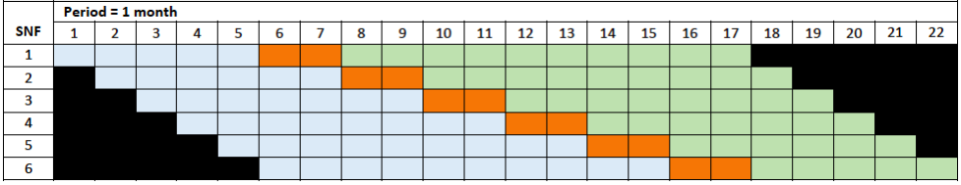

* The cluster period size is generated from a multinomial distribution having outcomes in (2,3,4,5,6) with probability (0.1,0.2,0.5,0.1,0.1). The cluster period size varies by period and by cluster.
* The continuous outcomes are generated based on the marginal mean model with linear period effect and the incremental intervention effect model shown below:

In the marginal mean model, the outcome $μ_{ijk}$ of patient k in cluster i and period j is associated with the average intervention effect and a linear period effect via the marginal mean model:

|  |  |
| --- | --- |
| $$g\left(μ_{ijk}\right)=β_{0 }+ β_{1 }t_{ij}+X_{ij}δ$$ | (1) |

where $β_{0 }$ is the intercept representing the mean outcome at the baseline under the control condition on the scale of the link function scale $g(.)$, $β_{1 }$ is the increment in the mean response for a unit increase in calendar period where g is a link function, β0 is the intercept, the {tij : j = 1, . . . , Ji} are integer-valued calendar periods $t_{ij}$, and $X_{ij}$ is the treatment status in cluster i at time point j, such as $X_{ij}=(j-b_{i})/q$ in intervention periods and 0 otherwise, with q=10.

* Clustered continuous data are randomly generated from marginal models above with an identity link function and correlation matrix under the nested exchangeable correlation structure with ICCs = (0.1, 0.05) by multinormal distribution.
* Baseline outcome for the models is chosen as 18.5. We assume a gently very small linear period effect such that β1 = 0.02 for tij = 1, ..., 22. Effect size at 10 months on treatment (q = 10) for the incremental intervention effects model is δ =3. The marginal variance of the outcome is set as 2.
* Because the patient preparedness is a sum score for 8 different questions with integer answer, I round the simulated continuous outcomes to the nearest integer for the analysis outcome. The results are recorded in the html results file.